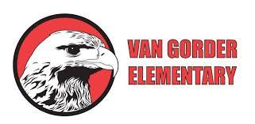

***Van Gorder Parent Faculty Association (PFA)***

***2024-2025 Membership Drive***

Parent Name (s): ___________________________________________________________

Email Address: ____________________________________________________________

**Please list all students attending Van Gorder Elementary School for the 2024-2025 School Year:**

Student Name: ____________________________ Teacher: _________________________

Student Name: ____________________________ Teacher: _________________________

Student Name: ____________________________ Teacher: _________________________

Student Name: ____________________________ Teacher: _________________________

**Your membership donation supports Van Gorder teachers and students in many different ways such as classroom incentives, field trips, technology, PE class, Teachers Appreciation Week, Sock Hop, and so much more!**

**Annual Family Membership Donation:**

**$25**

**Sign up by 9/12 and get 1 entry to win a gift basket.**

**Raffle winners will be announced during the Sock Hop on 9/13.**

*\*No school year volunteer time requirement is necessary to donate!*

**Ice Cream or Pizza Party for the top 2 classrooms with the highest PFA Membership enrollment!**